**Project Report**

**Intended Audience:**

* As our report is based on the Covid-19 cases in Toronto, our intended audience includes authorities from the healthcare department, central ministry and internal securities department so we can provide them with our analysis and recommendations i.e.,
  + Central Health Ministry
  + State Health Ministry
  + Senior Doctors of the state
  + Frontline Healthcare workers
  + Federal Authorities
  + Internal Securities department

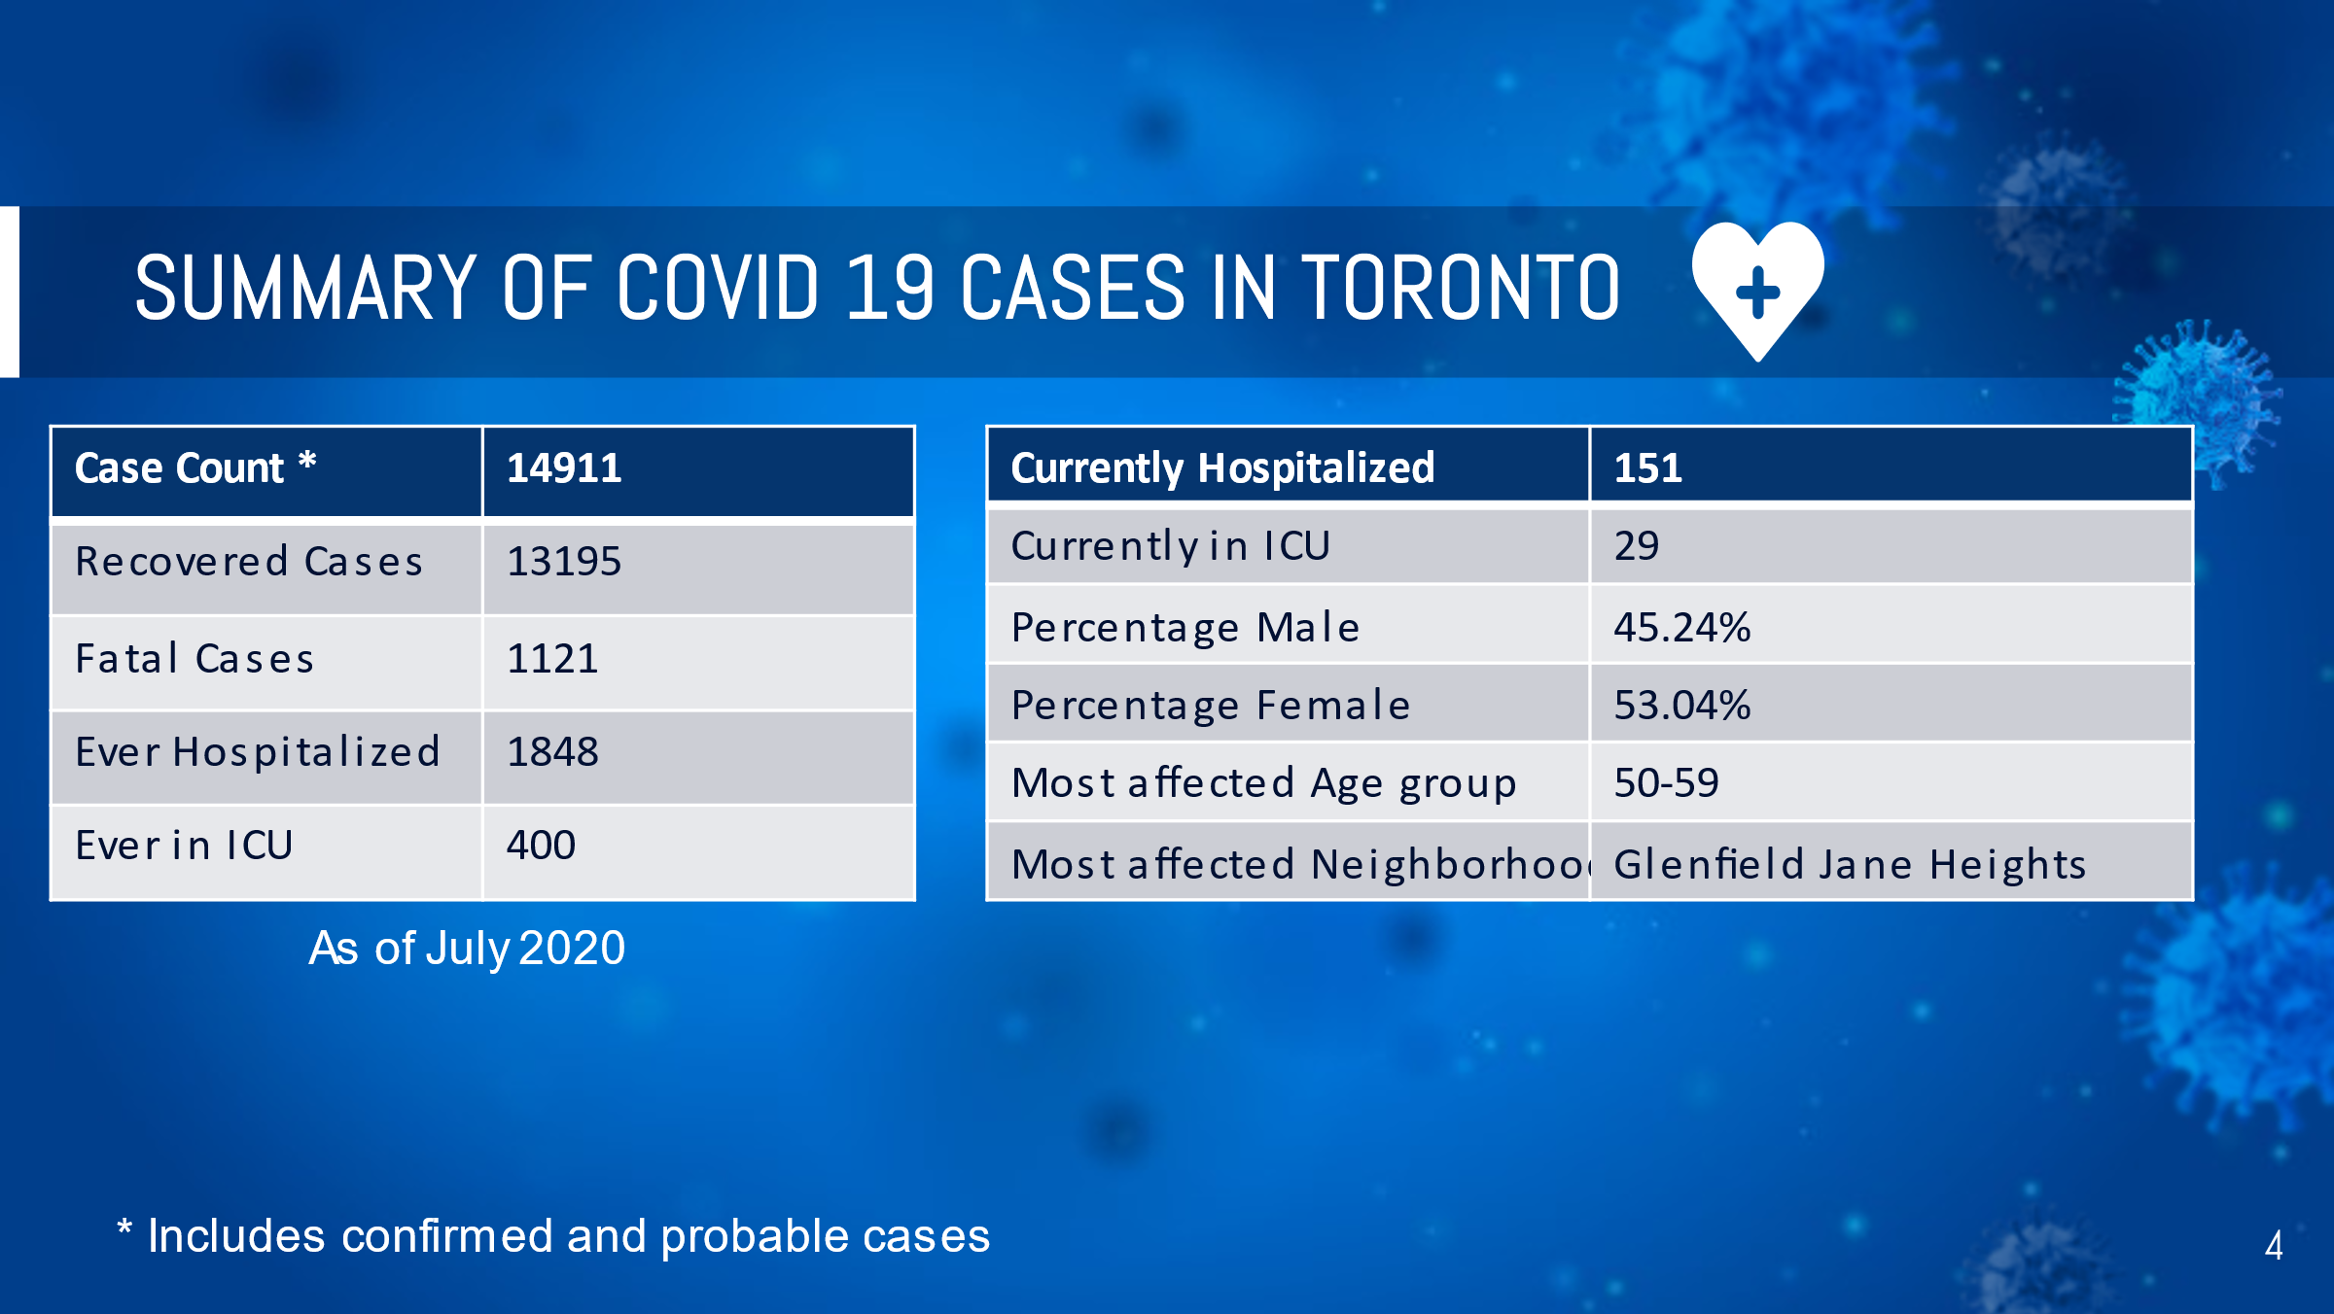

**Data Report:**

1. **Source of infection**

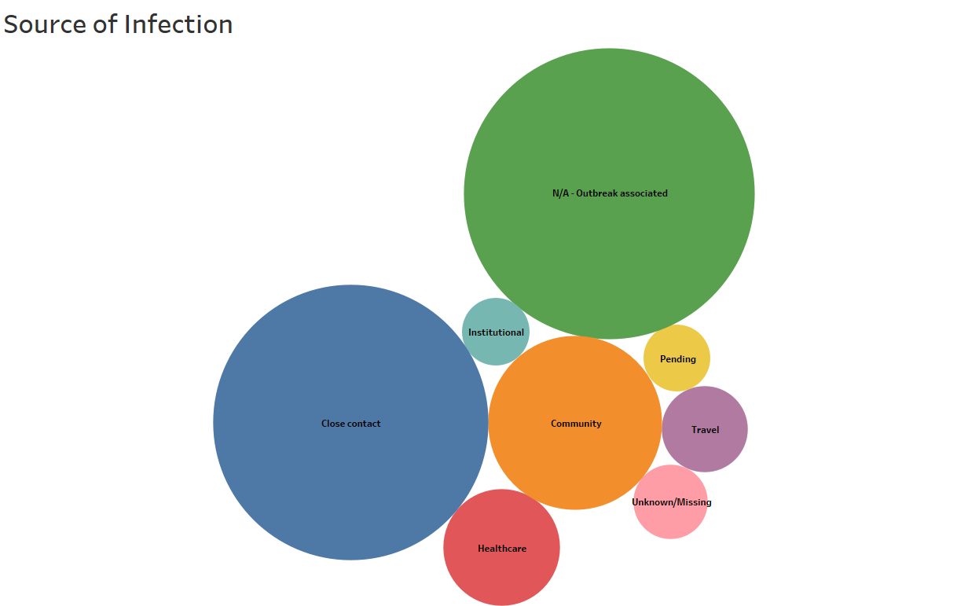

**Analysis:**

* To begin with, apart from the outbreak associated patients, the top sources of infection are infection due to close contact, community transmission and healthcare related transmission.
* These sources make up to approximately 85% of the total cases in Toronto.

**Recommendations:**

* After getting to know the sources which are most responsible for the increasing cases in Toronto, the authorities should be alert and increase the awareness of using masks and maintaining social distancing.
* The healthcare authorities should not allow anyone else to visit the patient as the chances of transmission increase while being near to the patient.
* Travel restrictions should be imposed and thermal testing should be mandatory at each point to reduce the transmission.

1. **Number of cases by AgeGroup**

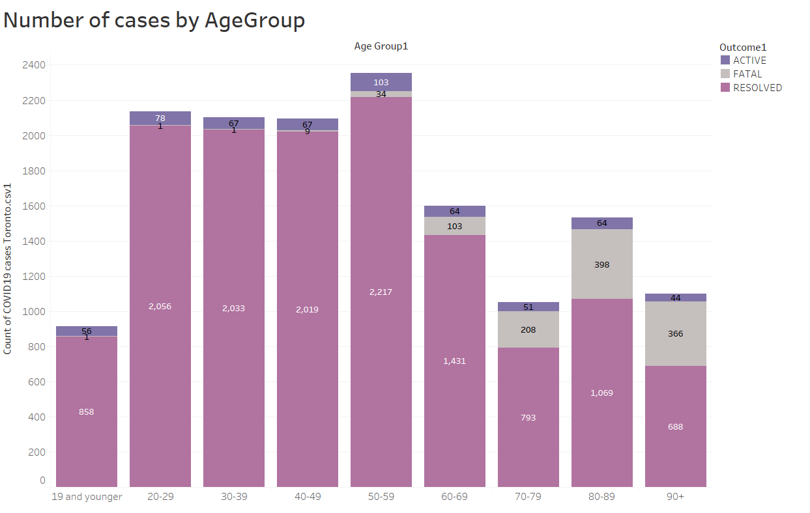

**Analysis**

* It can be seen that the Age group 50-59 is most affected by Covid-19 in Toronto, but it also has the highest number of resolved cases.
* Age group 80-89 has the 4th lowest number of cases but it has the highest number of deaths.
* The highest death rate is found in those who are 90+ (33.33%).

**Recommendations**

* Senior healthcare authorities and Hospitals should focus on the age groups which are most affected, especially those who are more vulnerable to the virus.
* Prioritize the age group having higher fatality rate over the younger age groups and provide better facilities to them.
* Older age groups should be prioritized over others for the vaccination drive, a systematic and an easy process should be developed for the vaccination to reduce the death/fatality rate.

1. **Top 10 most affected neighborhoods**

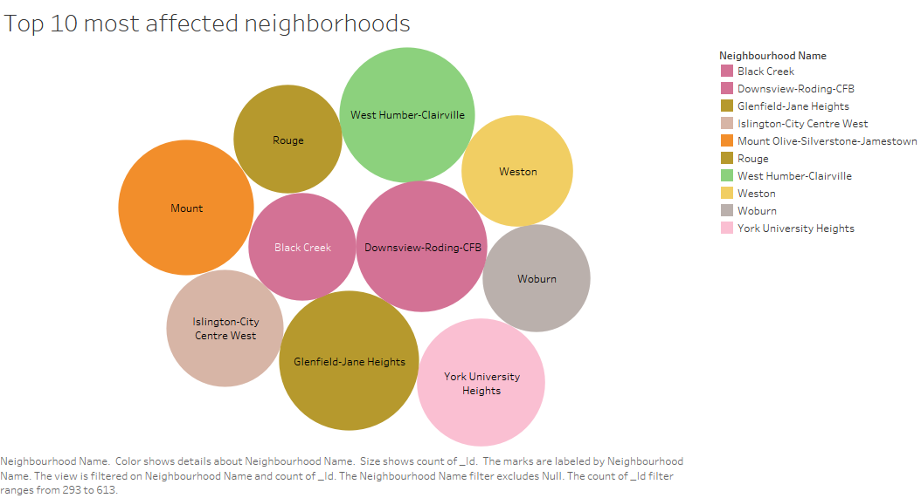

**Analysis:**

* As the packed bubbles suggest, these are the top 10 affected neighborhoods with Glenfield Jane Heights being the most affected one having 499 cases followed by West Humber-Clairville(470), Mount Olive-Silverstone-Jamestown(468), Downsview-Roding-CFB(434), York University Heights(420), Islington-City-Centre West(352), Weston(318), Rouge(302), Black Creek(294), Woburn(293).
* The count of patients includes active, fatal and resolved cases.

**Recommendations:**

* A suggestion to the federal authorities to dig deep and find out the occupation of the people in the most affected neighborhoods, check whether there is a trend of people with outdoor jobs like transport, delivery being infected more.
* Night curfew should be imposed in these areas to restrict the movement of people.
* Only people with work and genuine reasons should be allowed to enter these neighborhoods to reduce the community transmission.

1. **Bifurcation of top 10 neighborhoods with most cases by the source of infection**

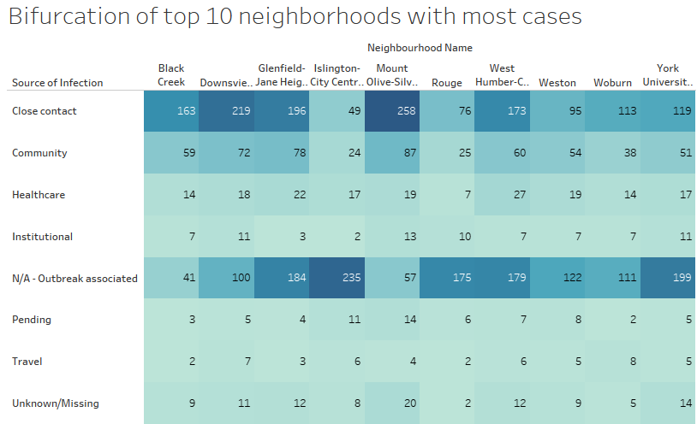

**Analysis:**

* This is a highlight table which bifurcates the top 10 neighborhoods with most cases by the various sources of infections.
* This is to determine that which source is been affecting people the most in these neighborhoods.
* In many of the neighborhoods, the primary sources were found to be close contact, community transmission, healthcare related and outbreak associated cases.

**Recommendations:**

* Post bifurcating, this analysis could be used to plan on the rules & regulations on areas which are showing a steady increase in the cases.
* For instance, Mount-Oliver-Silver-Jamestown had the most cases because of close contact, so strict rules regarding maintaining social distancing should be imposed in the surrounding neighborhood.
* Very few cases are there because of traveling, hence too much restrictions could be avoided here.

1. **Least affected neighborhoods**

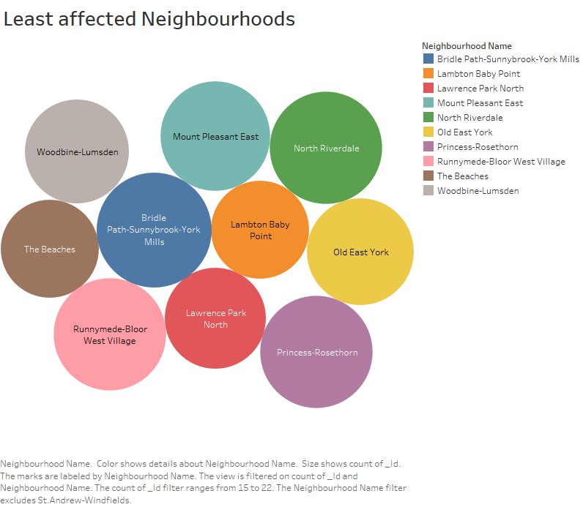

**Analysis:**

* As the packed bubbles suggest, these are the ten neighborhoods with lowest number of cases with Lambton baby point and the beaches being the least affected having just 16 cases followed by Lawrence park north (17), Woodbine -Lumsden (18), Old East York (19), Mount Pleasant East (20), Runnymede-Bloor West Village (21), North Riverdale (21), Princess-Rosethorn (21), Bridle Path-Sunnybrook-York-Mills (22).
* The count of patients includes active, fatal and resolved cases.

**Recommendations:**

* As the analysis suggest, these neighborhoods have been successful in limiting the spread of the virus.
* Hence, the authorities should try and implement the same model which was being followed in these areas to other affected neighborhoods too.
* Investigate on which methods were followed by the people which resulted in such less number of cases.

1. **Bifurcation of the 10 neighborhoods with least number of cases by source of infection**

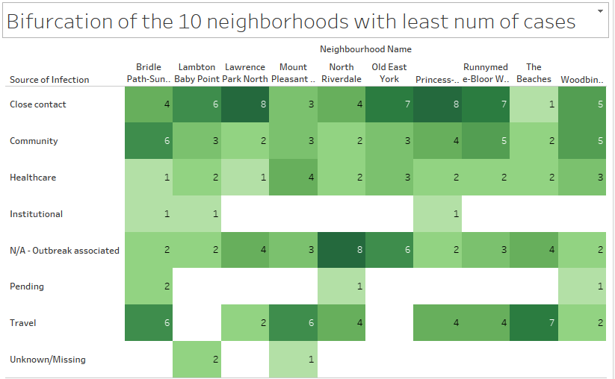

**Analysis:**

* This is a highlight table which bifurcates the ten neighborhoods with lowest number of cases by the various sources of infections.
* This is to determine the sources which are less or not even affecting the people in these neighborhoods.

**Recommendations:**

* In these neighborhoods, there have been even less than ten cases because of close contact which was the primary reason in the top 10 affected neighborhoods. Hence, the model followed here should be implemented in every other places as well.
* Healthcare related infection have been less in numbers as well. So, the methodology of the hospitals in these neighborhoods could be implemented in the hospitals of most affected places to restrict the spread.

1. **Number of cases reported each month by Gender**

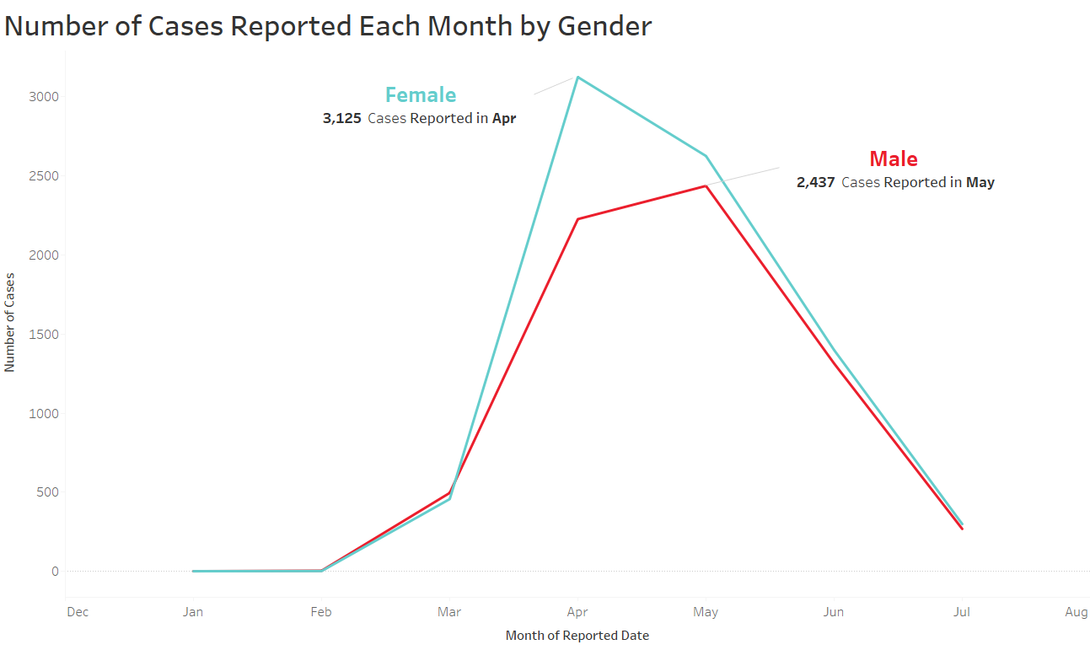

**Analysis:**

* The line chart shows the number of cases reported for Female were the highest in April (3125) and were the highest for Male in May (2437).
* The cases started to slow down post May as it shows a decreasing trend in the chart.

**Recommendations:**

* April & May had the highest number of cases for Female & Male, check for the events that happened during that time to make sure it does not happen again.
* The chart shows a decreasing trend post the month of May, which is actually a sign of success for the authorities. So, try and determine the reason why it started to decrease and use that analysis to keep the cases in control in future too.

1. **Patients hospitalized and ever admitted in ICU**

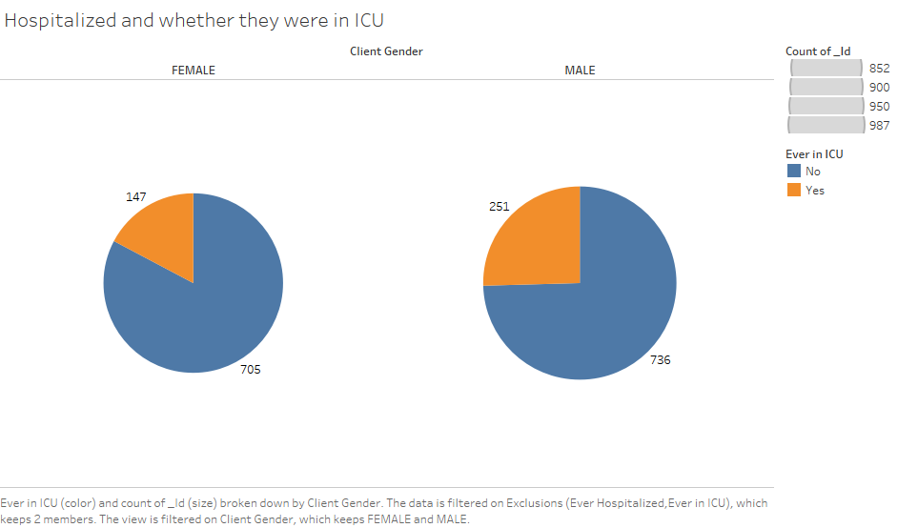

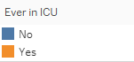

**Analysis:**

* 852 Females and 987 Males were ever hospitalized and out of them 147 Females and 251 were in ICU.
* Approximately 79% of the patients were recovered without any intensive treatment, and 21% of them had to be transferred to the ICU.

**Recommendations:**

* As most of the patients do not need the intensive treatment, the senior health authorities should examine the medicines and the treatment given to the patients because of which they were getting healthy.
* The number of beds in the ICU should be increased as to be prepared if there is a sudden rise in the number of cases.
* Prioritize the patients having diseases which could turn out to be fatal because of the virus and provide them with the ICU treatment.
* Few other general recommendations are
  + Create a centralized quarantine system as well as other methods to achieve effective isolation for individuals.
  + Increase the use of disinfectants by spraying it around the city.
  + Rebuild the design & implementation of ways to address the social determinants of health for City of Toronto’s most vulnerable population.
  + Increase the allocation of funds towards the healthcare so that even the financially challenged citizens could be treated.
  + Changes in rules & regulations regarding those who were in the close contact of the positive tested people, making them quarantine for few days.

**References:**

<https://graphics.reuters.com/world-coronavirus-tracker-and-maps/countries-and-territories/canada/>

<https://www.thrombosisresearch.com/article/S0049-3848(20)30157-2/fulltext>

<https://toronto.ctvnews.ca/toronto-s-top-doctor-releases-charts-showing-covid-19-data-suggests-second-wave-is-likely-1.4906087>